How to Place an Offer and Upload Attachments
**Please call or email Lila Laguna at NYSWDA should you have any problems or questions regarding these instructions, the use of BidSync or the actual bid. 518-690-0494 or llaguna@nywsda.org**
1) Go to www.bidsync.com

2) Click on My Account in the top, right-hand corner.

3) Register by clicking on the link that says Sign up now.
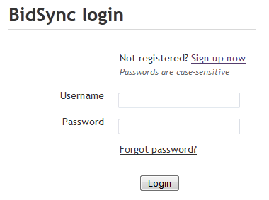
4) Once you have created an account and logged in, you will see a Search Bids box towards the top, center of your screen, type in the keyword for the bid NYSWDA. You may also select the Region where the bid takes place and then click GO.

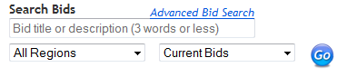

5) Once the search results come up, you will need to click on the link that says Link Bids in the orange bar above the search results.
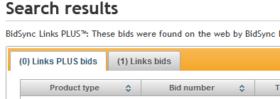

6) Click on the title of the bid that you are interested in.

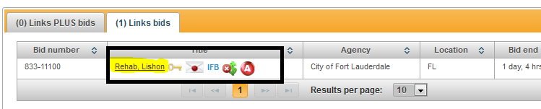

7) If you want to receive notifications about this bid, for example, when changes occur, a question is added, and pre-bid conference notifications; you will need to click on the button that says Notify me about this bid.

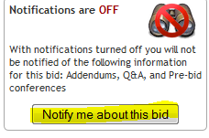
8) You should now be on the main page of the bid. To begin responding to the bid, you will need to click on the Documents tab.

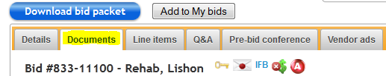

9) You will need to view or accept the documents that are listed under the document tab.

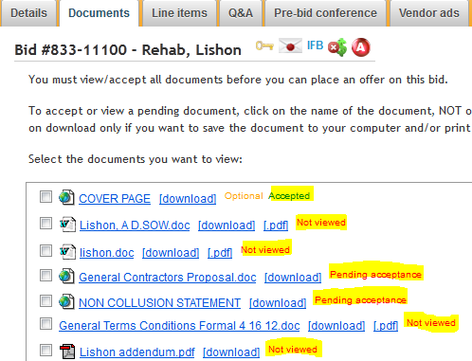

10) Once finished, you will be able to move onto the next step of responding to the bid. Scroll down to the bottom of the page, and click Place Offer.
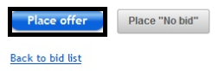
11) You will then come to the page where you enter in your pricing for the line items.
You will need to enter in values in the required fields (the product code is optional). If you have more than one offer you would like to make for a particular item. Click on the “Alternate offer” box.

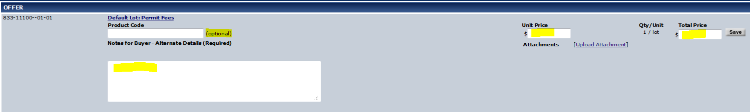
12) If you need to upload an attachment, you can click on the link that says Upload Attachment. This link is towards the right of the page, right under the pricing area. Attachments can include MSDS sheets, brochures on products, size sheets and any other relevant information. Bidders can upload multiple attachments for any offer on the bid, they do not need to be specific to the line item you are on. For example, while placing an offer on a window, you can upload attachments relevant to the window but also the MSDS on silicone caulk. Once your bid is opened, NYSWDA will be able to sort the attachments for our results page.

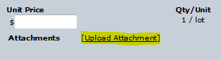

13) You should then see a window come up that should look like the picture below. Click on Browse.

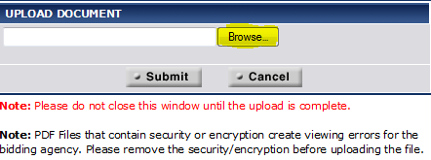

14) You will see a window where you will need to select the document, and click Open.
Then, click on Submit to upload your attachment.

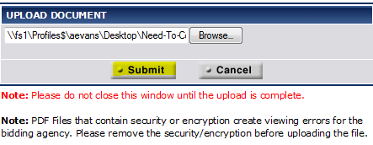

15) You will see a box that shows the progress of the document you are uploading. Do not close this window until it is finished uploading.
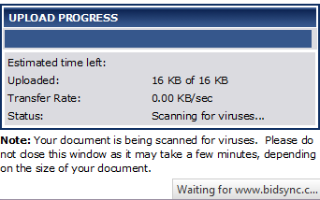
16) Once you finish entering all of the information in your bid response, you can click Submit. The next page will show you a summary of what you have entered in your response. You will need to put in your password to confirm the response.

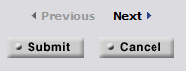

17) If you need to update your response, you may re-submit your bid up until the time that the bid closes. By re-submitting your response, it will not submit it twice, it will just update with what you most recently submitted.

18) Within a few minutes of confirming/submitting your bid. You will get an email from BidSync. The body of the email will list all the information about the items you bid. Print this and use it as your Bid Sync copies when gathering the documents listed on the checklist.

**Please call or email Lila Laguna at NYSWDA should you have any problems or questions regarding these instructions, the use of BidSync or the actual bid. 518-690-0494 or llaguna@nyswda.org**

